Hello.

I will introduce about socket program.

1. Run server.exe

First of all, serversocket is created.

Then the server listens to the client’s request.

That is, the server does nothing until client sends request.

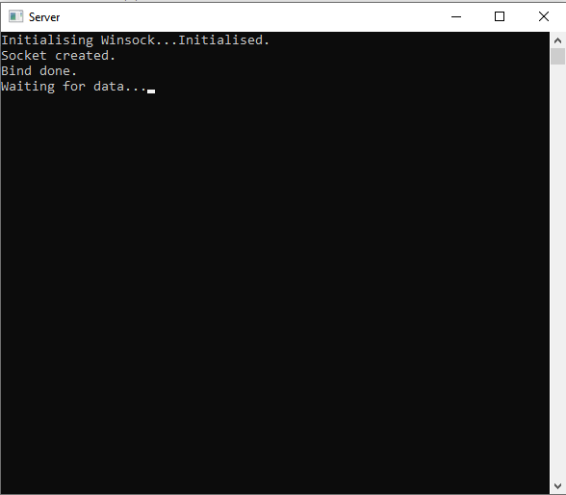

1. Run client.exe

As well as the server, the clientsocket is created for the first time.

Next, ‘Enter message’ is displayed.

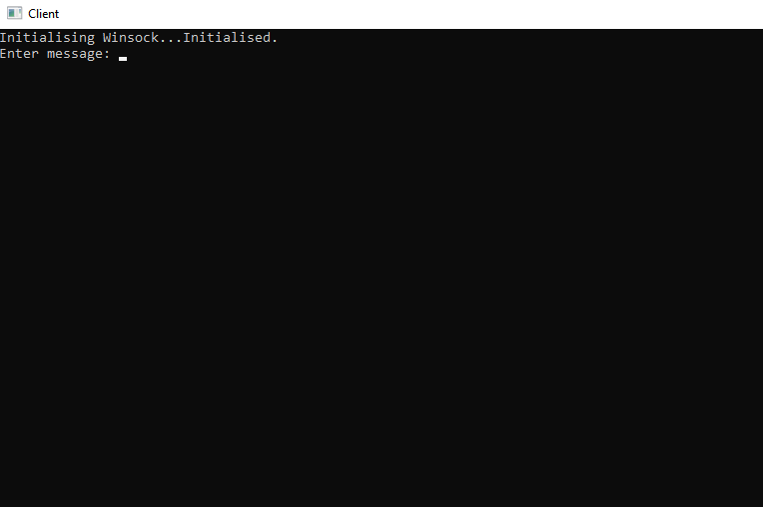

The client types any message, and press ‘Enter’.

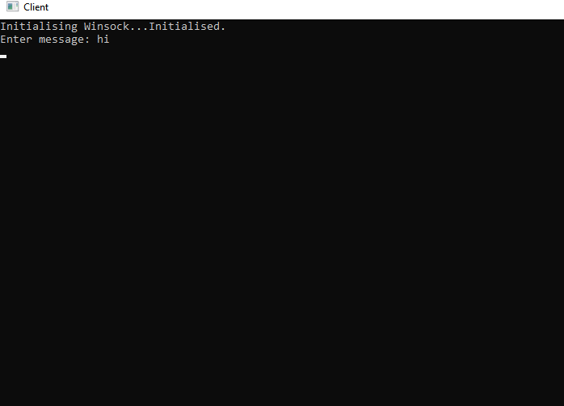

Then, the server receives packet from the client, and required infos(IP, TCP, UDP infos)are displayed in the server window.

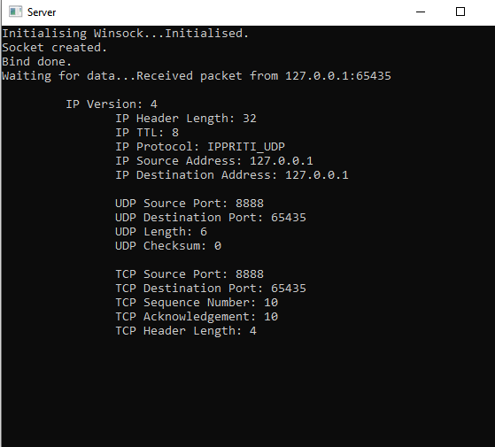

These infos are transmitted only once!

Then, the server and client can communicate each other. Also, all users can transmit message only after receiving message. (Please refer to video)

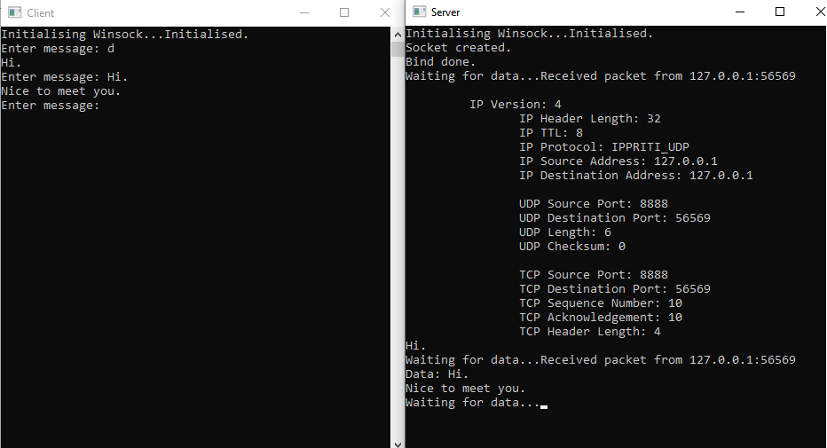

\*\*\*\* ‘makefile.win’ file isn’t needed for the running of program.

Thanks for your attention.